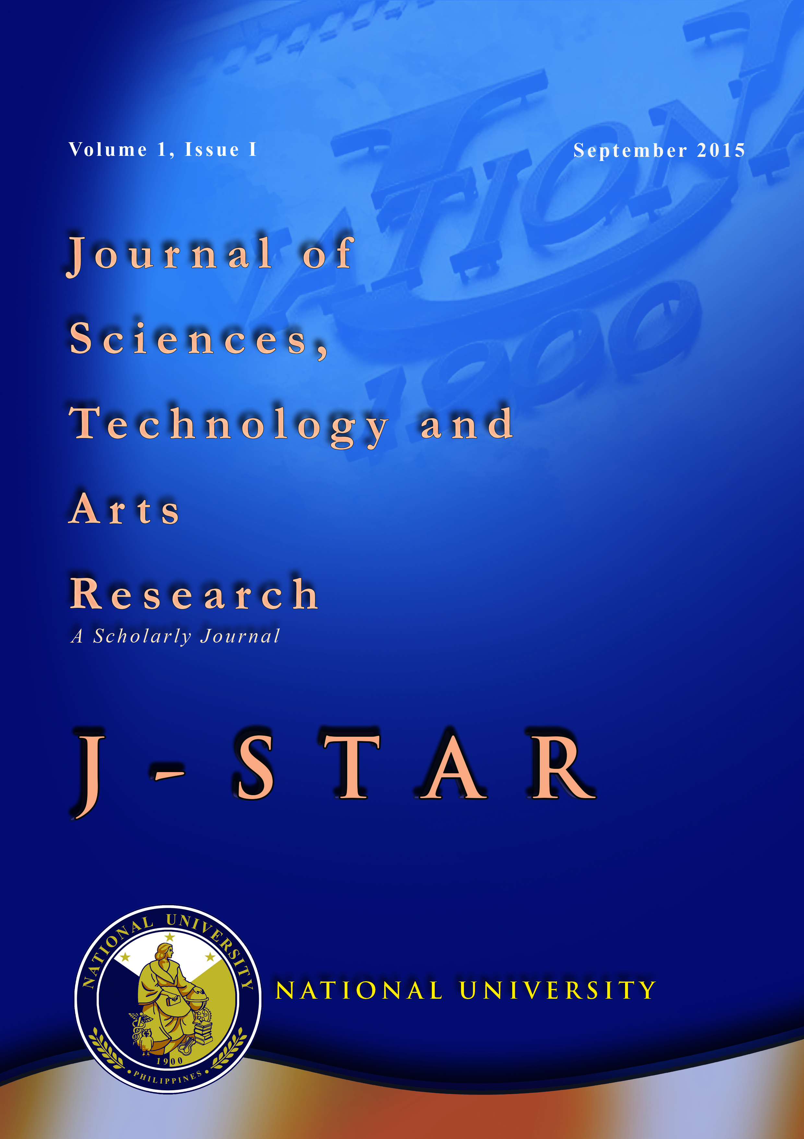
ISSN: 2467-5776 (Print Version)
Journal of Sciences, Technology and Arts Research is a peer reviewed journal published annually by National University Research and Innovation Office. The aim of this journal is to provide a venue for researchers, both students and teachers, to share their views, empirical studies, theories, and brief research reports related to sciences, technology, and arts. Articles are published in English.

Jessie S. Barrot, PhD
Editor

Philippe John F. Sipacio
Associate Editor

Ervin R. Samoza
Editorial Assistant

Editorial Advisers:
Renato Carlos H. Ermita Jr., Executive Vice President
Rachel Edita O. Roxas, Vice President for Academic Affairs
Ar. Chona E. Ponce, Dean, College of Architecture
Dr. Joseph D. Lim, Dean, College of Dentistry
Dr. Estrella F. Alabastro, Dean, College of Engineering
Dr. Leonora Concepcion, Dean, College of Nursing
Prof. Priscilla D. Miranda, Dean, College of Pharmacy
Dr. Remedios C. Cruz, Dean, College of Business and Accountancy
Prof. Rosauro E. Manuel, Dean, College of Computer Studies
Dr. Joel M. Durban, Dean, College of Education, Arts and Sciences
Dr. Rowena P. Sagaysay, Dean, College of Hospitality Management

FOREWORD


My congratulations on the first issue of the NU Journal under the aegis of the J-STAR team of the National University. This publication is reflective of the serious commitment of the time and energy that was put into the selected papers from the contributors of the different colleges addressing a wide spectrum of topics.

I hope that the compilations in this first volume would provide a starting place, a road map that will enable other faculty members to gain a broader perspective and understanding of the discipline and value of research in a university, its tangible benefits, and an encouragement to get involved in future research activities.

Furthermore, with this initial endeavor, it is my fervent desire to see our beloved National University become a major player in the field of academic research and to take its place among the highly regarded educational institutions engaged in this very important part of the learning process.

I would like to commend the J-STAR editorial team composed of Dr. Jessie Barrot as editor-in-chief and Mr. Philippe John Sipacio as associate editor as well as the editorial advisory board composed of Dr. Rachel Edita Roxas (VPAA) and the deans. Special thanks also to the peer reviewers who painstakingly provided valuable insights for the improvement of the papers. All of them deserve our thanks for their expertise and their efforts for taking the lead in making the first research output a reality.

Teodoro J. Ocampo
President, National University

FOREWORD


As we continue on in our quest to produce academic champions, we have once again achieved a new milestone that will positively contribute to this objective.

The first publication of the Journal of Sciences, Technology and Arts Research will stand as a testament to the commitment of National University to nurture and develop its faculty members to become capable researchers in their own fields of expertise.

We envision that, with continuous support, we will see the full development of the research culture of the University and we will be able to produce research output that may be pitted against the work of other distinguished researchers in the country and abroad.

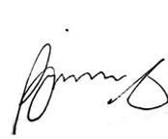
I acknowledge the effort of the NU RaIN Office for spearheading the first publication of the J-STAR. I also would like to commend the faculty authors, whose works are featured in this journal. Your pioneering efforts serve as an inspiration to all of us.

Let us continue to work for a better National U!

Renato Carlos H. Ermita, Jr.
Executive Vice President/COO

FOREWORD

Congratulations to our National University Community for forging towards new heights in research, one of which is the publication of the Journal for Science, Technology and Arts Research (or J-STAR)!
As the name J-STAR indicates, National University, through our researches, functions as a source of light and illuminates where we are planted towards social reform and nation building. NU's research agenda leads us through a path consistent with the goals of the Vision-Mission of the University and the national research agenda.
J-STAR is a reflection of the fulfillment of the three-pronged objectives of the University manifested through the Academic-Research-Community Engagement (or ARC) framework of the University, where one area reinforces the other. Our research complements our teaching and contributes to enrich our community engagement.
Once again, congratulations! Let us continuously work together towards our common goals.

Rachel Edita O. Roxas, PhD
Vice President for Academic Affairs, National University

Journal of Sciences, Technology and Arts Research
Volume 1, September 2015, pp. 1-52

Contents

Foreword: President i

Foreword: Executive Vice President ii

Foreword: Vice President for Academic Affairs iii

Linguist’s Assistant: Gleaning a Tagalog Lexicon and Grammar from a Small, 1-17
Lightly Annotated Corpus
Tod Allman, College of Computer Studies
Philippe John F. Sipacio, College of Education, Arts and Sciences

Internationalization at Home (IaH): National University a Potential Hub 18-28
Glendora V. Tiu, College of Education, Arts and Sciences

Witchebelles Anata Magcharot kay Mudra na Nagsusuba si Akech: Developing a 29-37
Rule-based Unidirectional Beki Lingo to Filipino Translator
Nathaniel Oco, Raymart Fajutagana, Christine Mae Lim, Judi Diane Miñon,
Julie-Ann Morano, & Ryan Christian Tinoco, College of Computer Studies

Accessibility of Deaf Education in the Mainstream Certificate Program of a 38-51
Private Tertiary Educational Institution in Manila
Christopher Manlapaz, College of Hospitality Management
Shirley Ann Joseph, De La Salle-College of Saint Benilde

